Supplementary Information
Progress and Policies to Achieve the Zero Pollution Action Plan and EU 2024/2881 PM2.5 Targets in Northern Italy
Laura Zecchi¹, Michele Francesco Arrighini¹, Claudio Marchesi^{1*}, Francesco Donato², Marialuisa Volta¹
¹ Department of Mechanical and Industrial Engineering, University of Brescia, Brescia, Italy
²Unit of Hygiene, Epidemiology and Public Health, Department of Medical and Surgical Specialties, Radiological Sciences and Public Health, University of Brescia, Brescia, Italy
* Corresponding author. Claudio Marchesi, Department of Mechanical and Industrial Engineering, University of Brescia, Via Branze 38, Brescia, Italy.
Email address: claudio.marchesi@unibs.it

S1. Emission source macro-sector classification
Air pollution sources are classified using CORINAIR SNAP 97 (Selected Nomenclature for Sources of Air Pollution – year 1997) classification, as shown in Table S1.
Table S1 Corinair Macrosector (MS) code and names, according to CORINAIR SNAP 97 classification
MS code | MS name
1 | Combustion in energy and transformation industries
2 | Non-industrial combustion plants
3 | Combustion in manufacturing industry
4 | Production processes
5 | Extraction and distribution of fossil fuels and geothermal energy
6 | Solvent and other product use
7 | Road transport
8 | Other mobile sources and machinery
9 | Waste treatment and disposal
10 | Agriculture

S2. Domain
The policy application domain is represented by the green area in Figure S1, covering the regions of Piedmont, Lombardy, Veneto, and Emilia-Romagna. To estimate the influence on air quality of boundary emissions, it is necessary, however, to consider a spatial domain that covers the entire Northern Italy (the gridded box in Figure S1 ). The whole domain was discretized into 92x59 cells with an area of 6x6 km² each, for a total of 5,890 cells, starting from the bottom-left corner at coordinates (310’279 m E, 4’844’657 m N, UTM Zone 32N).
The optimization domain consists of 2780 cells. In these cells, the emission reduction measures are applied, and the average concentration is used to compute the air quality index. The cells outside the four regions constitute the physical boundary of the problem; therefore, emissions are assumed constant, and no reduction measures are applied.
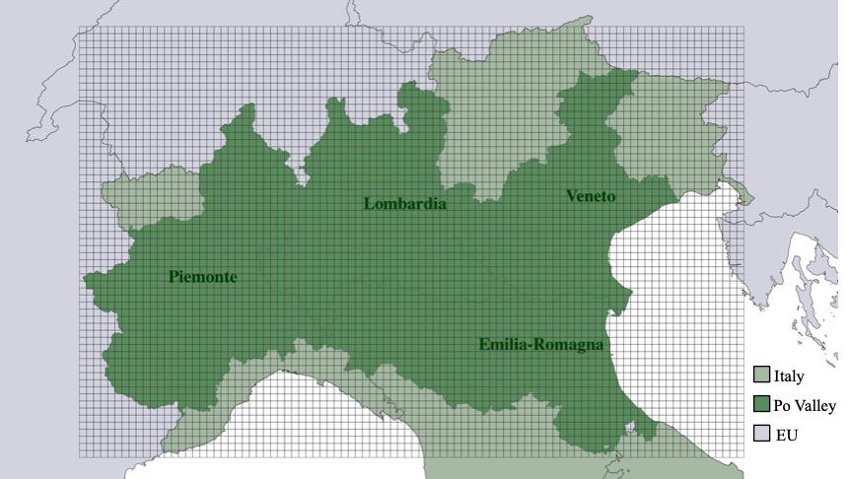
Figure S1. Gridded domain, divided between the measure application domain (dark green area) and the external domain. (Map generated using QGIS version 3.34. The shapefile of the boundaries were downloaded from ISTAT (https://www.istat.it/notizia/confini-delle-unita-amministrative-a-fini-statistici-al-1-gennaio-2018-2/. The dataset is licensed under Creative Commons Attribution 4.0 (CC BY 4.0 IT). The map was edited and annotated in QGIS.)

S3. Base-case scenario (BC2019)
This scenario represents the current situation and the starting point for future projection. In BC2019, no measures are applied beyond European legislation requirements for 2020. In Table S2 , the emissions of the BC2019 scenario are shown, considering only anthropogenic sources. Biogenic emissions are accounted for in the MAQ model but are treated as fixed inputs and are not subject to modification; they are included for the estimation of the PM2.5 concentrations.
Table S2. PM2.5 precursor (kton/year) and CO₂ (Mton/year) emissions of the BC2019 scenario. (Legend MS = Macrosector, NO_{x} = Nitrogen Oxides, VOC = Volatile Organic Compound, NH₃ = Ammonia, PPM10 = Primary PM10, PPM2.5 = Primary PM2.5, SO₂ = Sulphur Dioxide, CO₂ = Carbon Dioxide).
MS | NO_{x} | VOC | NH₃ | PPM10 | PPM2.5 | SO₂ | CO₂
1 | 20.47 | 1.98 | 0.11 | 0.27 | 0.24 | 5.10 | 28.78
2 | 29.03 | 29.88 | 1.15 | 30.63 | 28.75 | 1.75 | 35.30
3 | 36.07 | 7.99 | 0.39 | 2.78 | 2.02 | 13.37 | 26.34
4 | 7.18 | 35.28 | 0.18 | 1.52 | 0.84 | 8.07 | 4.34
5 | - | 17.49 | - | - | - | - | 2.87
6 | 0.39 | 165.41 | 0.04 | 1.83 | 1.60 | 0.02 | 0.00
7 | 142.24 | 35.89 | 2.28 | 12.12 | 5.98 | 0.24 | 42.82
8 | 37.59 | 4.64 | 0.01 | 1.96 | 1.85 | 0.58 | 3.91
9 | 0.89 | 0.63 | 1.53 | 0.83 | 0.73 | 0.18 | 2.70
10 | 1.67 | 173.18 | 215.05 | 2.28 | 0.50 | 0.12 | 17.93
TOTAL | 275.53 | 472.36 | 220.74 | 54.20 | 42.51 | 29.44 | 165.00

Figure S2 illustrates PM2.5 concentration spatial distribution for the BC2019 scenario, where the average PM2.5 concentration is 13.76 µg/m³.
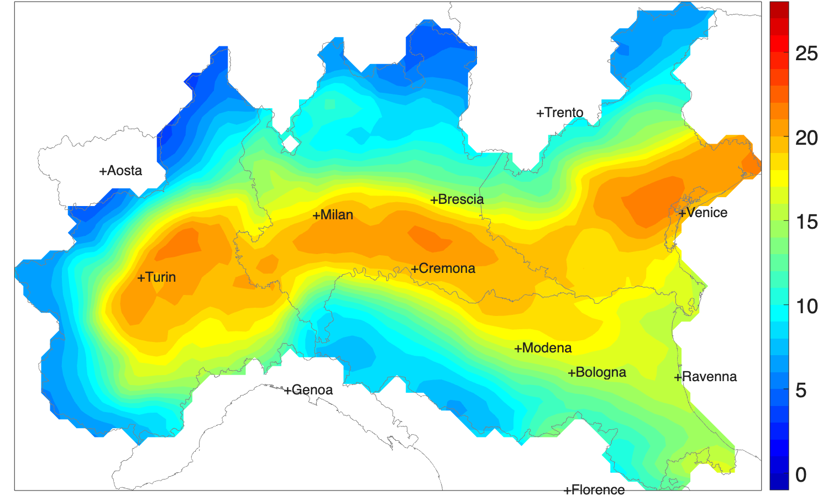
Figure S2. PM2.5 concentration in µg/m³ over the domain for BC2019 scenario. Figure created using MATLAB v.2024b (The MathWorks, Inc, Natick, MA, USA).

S4. Source-Receptor models
The link between emissions and pollutant concentrations is inherently non-linear, and it is modeled using Source Receptor Models (SRMs), as proposed in previous studies ^{1,2}. These models offer a computationally efficient alternative to full-scale Chemical and Transport Models (CTMs). A detailed description of the data sources used, the emission scenario design, the ANN training methodology, and the validation strategy is presented in the following sections.

Emission Scenarios and Training Dataset
In this study, a series of Artificial Neural Networks (ANNs) were trained processing a set of emission–concentration scenarios generated using the CTM model CAMx (https://www.camx.com/) The ANNs are trained to estimate pollutant concentrations from precursor emission inputs of each scenario. The source-receptor model is trained starting from a series of emission reduction scenarios (Table S3) simulated with the CAMx model. The simulations are subsequently used to train the source-receptor models. The scenarios are defined starting from a base case scenario, considering the emissions provided by INEMAR 2017 updated at 2019 and the meteorology of 2019.
The emission scenarios were obtained by systematically varying NO_{x}, VOC, NH₃, SO₂, PM10, and PM2.5 emissions within a range that spans between a 90% reduction to the maximum feasible scenario (i.e., when adopting all feasible reduction measures) and a 10% increase of the emissions imposed by the current legislation.
The percentage reductions $R\left(s,p\right)$ of each precursor p in each scenario is displayed in Table S3.
Table S3. Percentage reduction per precursors and scenario.
Scenario | NO_{x} | VOC | NH₃ | PPM | SO₂
1(HIGH) | 1 | 1 | 1 | 1 | 1
2(LOW) | 0 | 0 | 0 | 0 | 0
3 | 0 | 1 | 1 | 1 | 1
4 | 1 | 0 | 1 | 1 | 1
5 | 1 | 1 | 0 | 1 | 1
6 | 1 | 1 | 1 | 1 | 0
7 | 1 | 1 | 1 | 0 | 1
8 | 0.25 | 0.25 | 0.25 | 0.25 | 0.75
9 | 0.25 | 0.75 | 0.25 | 0.25 | 0.75
10 | 0.25 | 0.75 | 0.75 | 0.25 | 0.75
11 | 0.5 | 0.5 | 0.5 | 0.5 | 0.5
12 | 0.75 | 0.25 | 0.75 | 0.25 | 0.75
13 | 0.75 | 0.75 | 0.25 | 0.25 | 0.75
14 | 0.25 | 0.25 | 0.75 | 0.75 | 0.25

The final emission of each pollutant p in each scenario s ($E_{p,s})$ are computed as:
$$E_{p,s}=R\left(s,p\right)∙{(E}_{p,HIGH}-E_{p,LOW})+E_{p,LOW}$$
where $E_{p,HIGH}$ is the emissions of pollutant p in Scenario 1 (+10%) and $E_{p,LOW}$ the emissions in scenario 2 (-90%).
This process generates a dataset containing 14 x 5890 data points (i.e., the number of scenarios multiplied by the number of cells. A random subset comprising 90% of the data is used to train the artificial neural network, while the remaining 10% (i.e., 6986 values) is reserved for validation (see Validation section).

ANN Architecture and Inputs
Figure S3 illustrates the structure of the feedforward ANN. The input layer receives the annual total emissions of each precursor from the target cell and its neighboring quadrants, as well as the cell’s geographical coordinates (UTM) (Ferrari and Guariso ³). The input emissions are constructed in a way to consider the emission not only of the cell itself but also of the neighbors’ cell because, due to the transport flow in the atmosphere, the emissions generated at a point could influence the concentration in a certain radius, following the meteorologic conditions. The hidden layer applies non-linear activation functions (logsig and tansig) to capture the complex relationships between emissions and pollutant concentrations. The final output node returns the estimated concentration in the receptor cell.
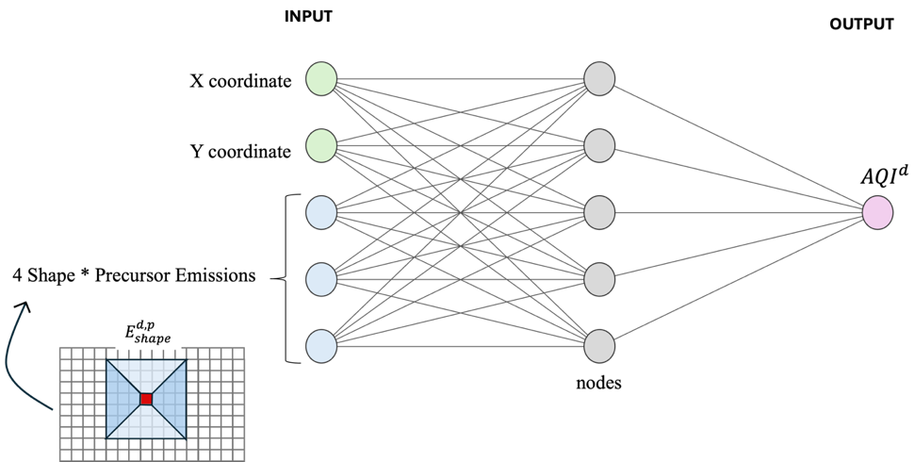
Figure S3. Artificial Neural Network architecture.

In this work, four different ANNs are trained: one for each region of the domain. Table S4 summarizes the hyperparameters of the networks used for PM2.5 concentration estimation. Each ANN has 20 input nodes, corresponding to the emissions of five precursors across four slices, plus two spatial coordinates.
Table S4. ANNs Hyperparameters
Hyperparameter | PM2.5 mean
Precursors | PM10, PM2.5, NO_{x}, NH₃, SO₂, VOC
Input nodes | 20
Layers | 2
f1 | logsig
f2 | Tansig
Radius (cell) | 4
Validation
A two-step validation was carried out: the first step consisted in the comparison of SRM output with the CTM simulations. assessing the capacity of the SRM to capture the variation of the concentrations for different precursor emission variation level.
Figure S4 shows the scatter plot of the validation set of CTM scenario and the ANNs performances in terms of correlation coefficient and normalized root mean squared error (NRMSE).

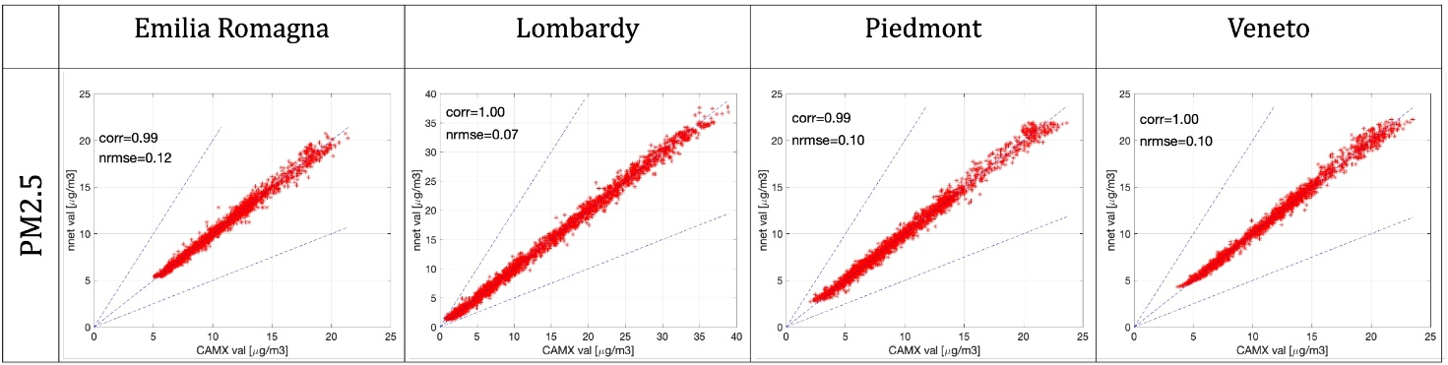
Figure S4. Validation scatter plot for PM2.5 and performances indexes for the four regions

The second validation procedure was performed comparing the SRM output with the data measured in the reference year. To validate the simulated PM2.5 concentration from the surrogate model in the base-case scenario (BC2019) were compared with the municipality-level yearly average concentration estimated by the European Environment Agency (EEA) for the year 2019 (https://www.eea.europa.eu/en/datahub/datahubitem-view/49930245-dc33-4c47-93b8-9512f0622ebc). The EEA data were available as annual mean values over the administrative boundaries of 29 cities in the Po A comparison between the concentrations simulated by the model and those reported by the EEA is presented in Table S5. The corresponding statistical performance indicators are summarized in Table S6 , showing a Pearson correlation coefficient (R²) of 0.770, a root mean square error (RMSE) of 2.395 µg/m³, a mean absolute error (MAE) of 1.851 µg/m³, and a standard deviation of 2.028 µg/m³.
Table S5. Annual mean PM2.5 concentrations (µg/m³): EEA data (2019) vs IAM BC2019 simulations
CITY | EEA 2019 | MAQ BC2019
Alessandria | 17.6 | 19.3
Asti | 17.8 | 19.5
Bergamo | 18.6 | 13.9
Bologna | 15.3 | 15.4
Brescia | 22.9 | 17.1
Busto Arsizio | 18.1 | 15.1
Como | 14.5 | 11.2
Cremona | 22.6 | 19.9
Ferrara | 18 | 17.6
Forlì | 14.9 | 14.1
Gallarate | 17.2 | 14.8
Lecco | 13.9 | 10.0
Milan | 19 | 18.5
Modena | 18.2 | 16.4
Novara | 18.3 | 17.3
Padua | 21.8 | 20.7
Parma | 17.6 | 14.6
Pavia | 19.1 | 19.7
Piacenza | 18.9 | 16.5
Ravenna | 17.2 | 15.5
Reggio nell'Emilia | 17.9 | 16.0
Rimini | 14.8 | 14.8
Sassuolo | 16 | 13.5
Turin | 19.8 | 20.1
Treviso | 21.4 | 20.7
Varese | 14.9 | 13.0
Venice | 17 | 20.7
Verona | 21 | 16.1
Vicenza | 24.3 | 19.0

Table S6. Annual mean PM2.5 concentrations (µg/m³): EEA data (2019) vs IAM BC2019 simulation.
Index | Value
R² | 0.770
MAE (µg/m³) | 1.851
RMSE (µg/m³) | 2.395
NMAE | 0.102
σ (µg/m³) | 2.028

S5. CLE2030 projections including PNIEC
The CLE2030 projection is derived by processing GAINS 2030⁴ estimations, based on the "EU Outlook 2017" and the Italian energy and climate strategy plan (PNIEC)⁵. The plan delineates the decrease in fuel use by 2030, concentrating on the main energy sectors: power production, residential heating, industrial combustion, and transportation. For the energy production sector, the PNIEC precisely defines the share of total production that will be generated by renewable energy sources (RESs) and the share that will still be produced by traditional plants (column "CLE2030" of Table S7). From this data, it is possible to figure out the expected percentage drop by comparing the value with that of the base case taken from TERNA⁶
Table S7. Energy consumption and production (divided into renewable and not renewable energy sources) at BC2019 from TERNA and projection to 2030 from PNIEC. The table shows the percentage variation in 2030 relative to BC2019.
 | BC2019 | CLE2030 | Variation [%]
Total energy consumption | 326’803 GWh | 339’596 GWh | +4%
Energy production | 283’950 GWh | 331’400 GWh | +17%
of which RESs | 88’216 GWh | 186’800 GWh | +112%
of which not RESs | 195’733 GWh | 144’600 GWh | –26%
The 26% reduction in production from non-renewable sources is partially attributed to the phase-out of coal power plants, while the remaining portion aligns with the projections outlined in GAINS scenario⁴.
For the domestic sector, consumption in 2019 and 2030 projections are obtained from PNIEC ⁷, as reported in Table S8.
Table S8. Energy consumption in the domestic sector divided by non-renewable and renewable energy sources (RESs) in 2019 and 2030 projection, and the percentage variation.
 | BC2019 | CLE2030 | variation %
Total consumption | 618’250 GWh | 58’6524 GWh | –5%
of which RESs | 47’799 GWh | 56’707 GWh | +19%
of which not RESs | 570’451 GWh | 529’816 GWh | –7%
In the industrial sector, the PNIEC⁷ plan anticipates a reduction of 31,928 GWh by the year 2030, relative to the year 2019. The TERNA report⁶ indicates that the industrial sector's consumption in 2019 was 128,940 GWh. Consequently, the projected energy savings for 2030 are estimated to be around 25%.
Finally, the target set by the PNIEC for the transport sector by 2030 is to achieve a total of 4 million electric cars in circulation within Italy. The projection indicates that the number of vehicles in circulation in 2030 is expected to remain approximately the same as the current figure, which is 40 million vehicles in Italy⁸.
Table S9 provides a summary of the targets.
Table S9. PNIEC target to 2030. Reduction in fuel consumption to be achieved by 2030
Sector | 2030 vs. 2020 variation
Energy production by non-renewable sources | –26%
Fuel consumption in domestic heating | –7%
Industry fuel consumption | –25%
Diffusion of electric cars | +10%

S6. Decision Problem
Control variables
The control variables ${(π}_{x})$are the degree of adoption of the emission reduction measures $x∈X$, grouped in end-of-pipe measures and energy measures. The end-of-pipe measures (g) reduce pollutant emissions without changing the activity level of the sources, while the energy measures (f, s) directly reduce the energy consumption of a certain activity, consequently modifying the activity level. A particular category of energy measures is the fuel switch measures (s), that consists in a shift of fuel use in a particular activity with another one that is less consuming.
The emissions for pollutant p and cell d are calculated as in (1) introducing non linearities between emissions and control variables:
$$\begin{aligned}E_{p}\left(π_{x}\right)=\sum_{d}{\sum_{k}{\left[A_{k}^{d}{∙ef}_{k}^{p}∙\left(1-\left(\sum_{s∈S_{k}}{ϕ_{s}}+\sum_{f∈F_{k}}{ψ_{f}}\right)\right)∙\left(1-\sum_{g∈G_{k}}{{eff}_{m}^{p}∙}γ_{g}\right)\right]}} \#\left(1\right)\end{aligned}$$
where:
$π_{x}=\left\{γ_{g},ψ_{f}, ϕ_{s}\right\}$ are the decision variables, that is the degrees of adoption of the end-of-pipe measure $g$, fuel consumption measure $f$, and fuel switch measure $s$, respectively.
$X=\left\{G,F,S\right\}$ denotes the set of the emission reduction measures
$F_{k}$, $S_{k}$, and $G_{k}$ represent the sets of fuel consumption, fuel switch measures, and end-of-pipe measures, respectively, applicable to the k-th activity.
$A_{k}^{d}$ denotes the level of the activity k in cell d
${ef}_{k}^{p}$ is the emission factor of the precursor p for the activity k
${eff}_{m}^{p}$ is the removal efficiency of end-of-pipe measure m for the precursor p
The feasible set of the decision variables is $Π=\left\{Γ∪Φ∪Ψ\right\}$, where $Γ$ is the feasible set of the end-of-pipe control variables $γ_{m}$, $Ψ$ is the feasible set of the fuel consumption control variables $ψ_{f}$, and $Φ$ is the feasible set of the fuel switch control variables $ϕ_{s}$.
Constraints
The constraints imposed on the control variables are reported in this section and described separately per end-of-pipe and energy measures.
For technological measures:
Application feasibility: the application level of the single measure $γ_{g}$ can vary between a minimum ($γ_{g}^{MIN}$) and maximum ($γ_{g}^{MAX}$) value. The minimum value is usually the degree of application mandated in the base case by the Current LEgislation (CLE). If a technology can be replaced, e.g., if a more efficient technology exists for the same activity, the minimum value is fixed at zero. A measure, sometimes, is not applicable to all the specific activity-fuel sources in the domain due to applicability problems; therefore, this value could also be lower than 100% in some cases.
$$\begin{aligned}γ_{g}^{MIN}≤γ_{g}≤γ_{g}^{MAX} \#\#\#\#\end{aligned}$$
Mutual exclusion: on a single activity, the application of different technologies that reduce a defined precursor (${G_{k}}^{p}$) cannot exceed 100%, i.e., reductions cannot overlap.
$$\begin{aligned}\underset{g∈{G_{k}}^{p}}{∑}γ_{g}≤1 \#\#\#\#\#\#\#\#\#\end{aligned}$$
Progressive emission reduction: the total emissions in each new scenario must be lower than or equal to the base case (CLE) for each activity. Thus, the emissions removed by the technologies applied for each activity must be greater than in CLE.
$$\sum_{g∈G_{k}}{{eff}_{g}^{p}∙γ_{g}}≥ \sum_{g∈G_{k}}{{eff}_{g}^{p}∙γ_{g}^{CLE}} ∀k$$
Overall lower limit: For each activity, the total application of measures cannot be less than the CLE. This means that it is not possible to dismiss measures applied in the base case unless replaced by more efficient ones.
$$\sum_{g∈G_{k}}{{eff}_{g}^{p}∙γ_{g}}≥ \sum_{g∈G_{k}}{{eff}_{g}^{p}∙γ_{g}^{CLE}} ∀k$$
For energy and fuel switch measures:
Application feasibility of energy measures: the level of application in the base case is zero, so the degree of application must be greater than zero and less than an upper limit.
$$0≤ψ_{f}≤ψ_{f}^{MAX}$$
Application feasibility of switch measures: As mentioned above, switch measures have a passive and an active component. In this case, the active measure follows the same logic as energy measures.
$$\begin{aligned}0≤ϕ_{s}^{ACT}≤ϕ_{s}^{MAX}\#\end{aligned}$$
Mutual exclusion: the activity level cannot be reduced by more than 100 percent.
$$\begin{aligned}\sum_{f∈F_{k}}{ψ_{f}}+\sum_{s∈S_{k}}{ϕ_{s}}≤1\#\end{aligned}$$
Energy conservation: when substituting fuel use, it is necessary to guarantee the preservation of the shifted energy. Thus, the overall energy replaced must be equivalent to the energy added by the substitutive activity. For each switch couple of activity-fuel ($act,sub$), the energy conservation constrain is:
$$\sum_{d}{A_{act}^{d}∙ϕ_{act}}=\left|\sum_{d}{A_{sub}^{d}}∙ϕ_{sub}\right|$$

S7. Multi-objective optimization results
Figure S5 illustrates the solution of the multi-objective optimization within the objective space defined by policy cost and PM2.5 concentration. The CLE2030 scenario denotes the initiation of the optimization process, whereas MFR2030 indicates the Maximum Feasible Reduction that can be attained in the absence of cost constraints. Every point on the curve represents an optimal solution, as it is not possible to achieve outcomes below the curve. The solution at 300 M€, referred to as “OPT”, is examined as it approaches the optimal trade-off point situated at the elbow of the curve, where additional reductions in PM2.5 concentration led to significantly increased policy costs (and vice versa).
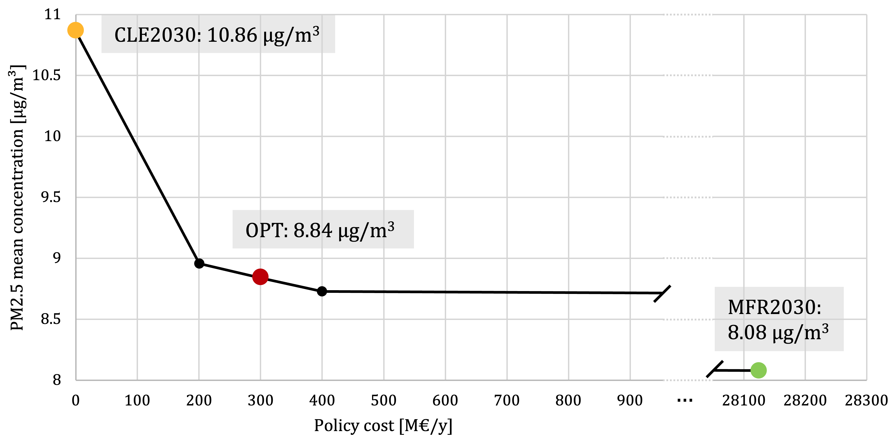
Figure S5. Pareto curve of the multi-objective optimization.

The total cost of the OPT solution is 300 M€. This cost is spread on the Corinair macrosectors and is divided into energy measures and technological measures, as in Figure S6.
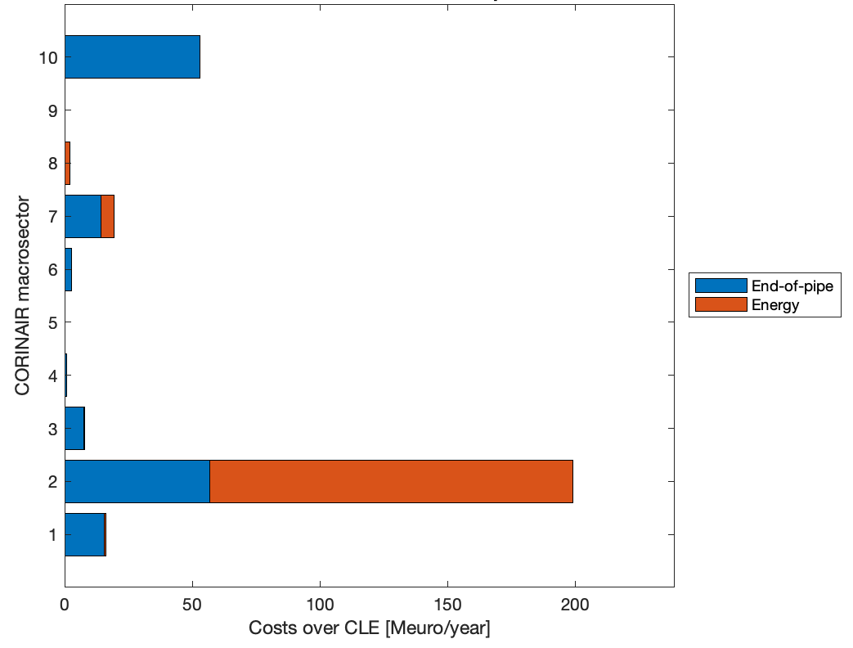
Figure S6. Subdivision of policy costs for the OPT2030 solution, by macrosector and type of measures.

S8. PM2.5 concentrations
Figure S7 shows PM2.5 concentrations over the domain for CLE2030 and OPT2030 scenarios.
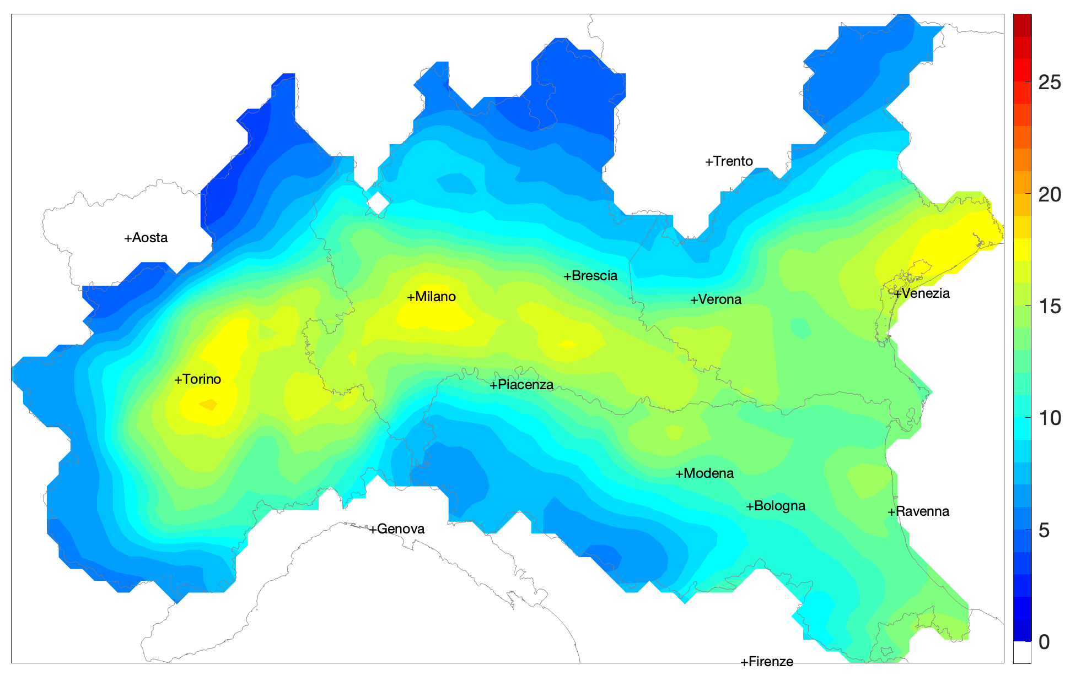
(a)
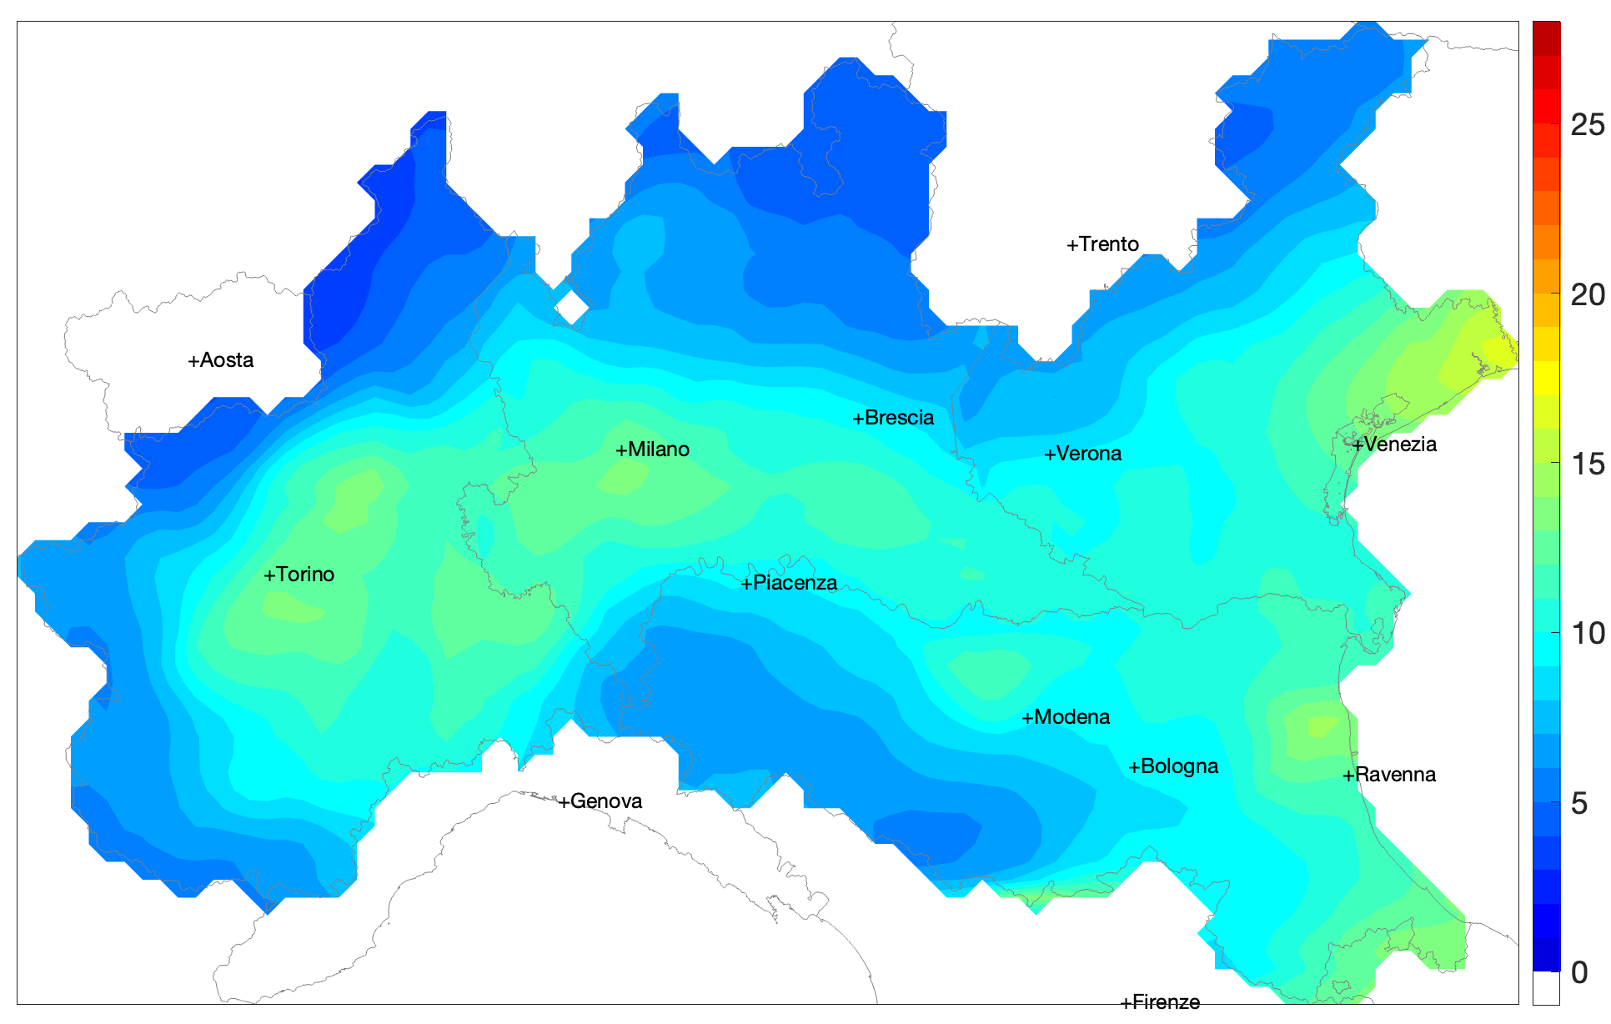
(b)
Figure S7. PM2.5 concentrations in µg/m³ over the domain for CLE2030 (a) and OPT2030 (b) scenarios. Figure created using MATLAB v.2024b (The MathWorks, Inc, Natick, MA, USA).

S9. Health impact assessment
Attributable deaths over 100k inhabitants for the two EEA dataset (2005 and 2019) and the two 2030 projections are reported in Table S10.
Table S10. Premature deaths per 100000 inhabitants across 29 municipalities in the Po Valley for 2005, 2019 (EEA data), and projections for 2030 under the baseline scenario (CLE 2030) and enhanced air quality scenario (OPT 2030)).
City | Pop 2019 | AD 2005 | AD 2019 | AD CLE2030 | AD OPT2030
Alessandria | 93191 | 180 | 116 | 98 (75-122) | 68 (49-90)
Asti | 75591 | 198 | 117 | 95 (73-119) | 59 (41-80)
Bergamo | 120569 | 193 | 112 | 55 (37-75) | 30 (13-46)
Bologna | 393248 | 162 | 86 | 57 (42-74) | 36 (22-51)
Brescia | 196134 | 176 | 132 | 62 (45-81) | 37 (21-54)
Busto Arsizio | 83549 | 167 | 103 | 61 (43-81) | 42 (25-61)
Como | 85979 | 159 | 82 | 51 (32-72) | 25 (8-44)
Cremona | 72274 | 202 | 143 | 81 (61-104) | 44 (26-63)
Ferrara | 132931 | 187 | 123 | 74 (55-94) | 53 (36-71)
Forlì | 118360 | 119 | 84 | 58 (42-76) | 45 (30-61)
Gallarate | 54015 | 152 | 89 | 54 (38-72) | 37 (22-54)
Lecco | 48265 | 172 | 76 | 36 (19-54) | 18 (1-36)
Milan | 1395980 | 213 | 98 | 81 (63-102) | 53 (37-70)
Modena | 189016 | 141 | 98 | 56 (42-72) | 36 (23-50)
Novara | 103278 | 165 | 104 | 78 (60-99) | 49 (34-67)
Padua | 209995 | 196 | 142 | 81 (61-102) | 49 (32-67)
Parma | 198606 | 150 | 91 | 44 (31-58) | 25 (14-38)
Pavia | 71943 | 188 | 130 | 94 (70-119) | 59 (39-81)
Piacenza | 103904 | 178 | 114 | 57 (42-73) | 34 (20-50)
Ravenna | 158923 | 118 | 105 | 73 (55-91) | 62 (46-81)
Reggio Emilia | 170887 | 125 | 86 | 52 (38-66) | 36 (25-48)
Rimini | 148981 | 96 | 88 | 75 (56-95) | 66 (49-85)
Sassuolo | 40373 | 105 | 77 | 35 (24-48) | 23 (11-35)
Turin | 860793 | 190 | 124 | 90 (69-111) | 63 (45-83)
Treviso | 85236 | 181 | 139 | 89 (68-112) | 61 (43-81)
Varese | 80876 | 163 | 84 | 54 (37-74) | 31 (14-49)
Venice | 259961 | 152 | 109 | 102 (79-126) | 72 (53-94)
Verona | 258584 | 172 | 121 | 49 (34-65) | 28 (14-43)
Vicenza | 109837 | 172 | 139 | 63 (46-82) | 36 (22-51)

References

1 Clappier A, Pisoni E, Thunis P. A new approach to design source–receptor relationships for air quality modelling. Environmental Modelling & Software 2015; 74: 66–74.
2 Wang MY, Yim SHL, Dong GH, Ho KF, Wong DC. Mapping ozone source-receptor relationship and apportioning the health impact in the Pearl River Delta region using adjoint sensitivity analysis. Atmos Environ 2020; 222: 117026.
3 Ferrari L, Guariso G. Geography-based Neural Networks for the Simulation of Air Pollution. IFAC-PapersOnLine 2023; 56: 8296–301.
4 Greenhouse Gas and Air Pollution Interactions and Synergies (GAINS) | IIASA. https://iiasa.ac.at/models-tools-data/gains (accessed Jan 14, 2025).
5 Dello M, Economico S. PIANO NAZIONALE INTEGRATO PER L’ENERGIA E IL CLIMA. .
6 Pubblicazioni Statistiche - Terna spa. https://www.terna.it/it/sistema-elettrico/statistiche/pubblicazioni-statistiche (accessed Jan 20, 2025).
7 Energia e Clima 2030 | Ministero dell’Ambiente e della Sicurezza Energetica. https://www.mase.gov.it/energia/energia-e-clima-2030 (accessed Jan 14, 2025).
8 Sistema statistico nazionale Istituto nazionale di statistica. 2020. www.istat.it (accessed Jan 20, 2025).

