Language as a tool to achieve the gender gap: examining the use and attitudes toward gender-inclusive language in top echelon positions

Abstract
Framing of the research. Feminine job titles are grammatically correct. Better yet, they align with the general behavior of Italian personal nouns, unlike the use of masculine forms to address women, which displays an unusual mismatch between a term and its referent’s gender. Moreover, such use is asymmetric and elicits undesirable psychological effects, such as evoking male images, lowering women’s interest in a job offer and their perceived fitness for a position, also the top echelon ones. Notwithstanding, the use of feminine job titles is still widely resisted.
Purpose of the paper. The present study investigated the extent to which feminine terms referring to the top echelon positions are widespread and whether such terms elicit an emotionally laden attitude, either positively or negatively. The study analyses the evolution in the use of the terms identified for research and the public’s positive or negative attitude toward them.
Methodology. Twitter was used as the data source, and an Italian-language corpus-specific sentiment analysis algorithm FEEL-IT was applied.
Results. We found an increase over time in the use of feminine terms. A difference in attitude within the various keywords. A positive and negative attitude has also evolved over time.
Research limitations. The difficulty was identifying a search key that allows downloading relevant tweets.
Managerial implications. As one of the most powerful ways implicit bias (i.e. automatic and unconscious beliefs) can act is through language, a robust understanding of the public’s positive or negative attitude toward feminine terms can contribute to the gender achievement gap in top echelon positions.
Originality of the paper. To the best of our knowledge, we used Twitter for the first time as a data source to perform a sociolinguistic study about feminine terms referring to the top echelon positions and map the evolution of selected terms within public opinion.

Keywords: top echelon, inclusive language, gender, Twitter, NLP, sentiment analysis

1. Introduction
“A father and his son are hit by a car. The father dies and the boy is brought to the hospital where, however, the surgeon says ‘I cannot operate on him: he’s my son’. How is it possible?” This old riddle keeps troubling guessers, as Belle et al. 2021 and Morehouse et al. 2022 show, who struggle to provide the most likely solution: the surgeon is the boy’s mother. Unlike English, Italian marks gender on every noun, so “surgeon” has to be either feminine or masculine in an Italian version of the riddle (De Francisco 1992). Intuitively, using it in the masculine would make the riddle even more difficult to solve while, on the contrary, using it in the feminine would dispel the enigma. Thus, while the English word lacks a gender specification and allows for stereotypes, such as that according to which surgeons are men, to inform the answer, Italian forces the speaker to choose a gender for “surgeon”, either supporting or challenging the stereotypes. This example shows, on an intuitive level, that using feminine professional titles makes women visible while using masculine ones reinforces the stereotype that, e.g., entrepreneurs, board members, and administrators are men (Shambaugh 2008; Coffman 2014; Bordalo et al. 2016; Dutt et al. 2016; Wu 2018; Bohren et al. 2019; Carlana 2019; Giusta and Bosworth 2020). This point is supported by several empirical studies (see Sczesny et al. 2016 and Gygax et al. 2021 for an overview) showing that masculine terms evoke male mental images. For instance, Stahlberg et al. (2001) found that respondents were likelier to list men than women if a question was posed in the masculine. Presumably, then, using masculine professional titles would make it more difficult to think of women when nominating for promotions or top echelon potions. Furthermore, specific experiments showed that women are more interested in entrepreneurship programs (Alesina et al. 2018; Hentschel et al. 2018) and children, regardless of gender, in job positions (Vervecken et al. 2013; Vervecken and Hannover 2015) when these are advertised using feminine professional titles. Moreover, women are evaluated as a fitter for a position if the latter is described with feminine terms as well (Horvath and Sczesny 2016). So, language does not merely reflect reality, but influences it. In particular, language directs our attention towards certain aspects, making them salient, and away from others, making them more difficult to notice. Moreover, language is not simply a passive means through which we express ourselves, but can and is constantly used to modify reality: as John Austin 1962 famously showed, we do things with our words. Language and deeds do not belong to separate worlds but are strictly connected. We describe what we do with language, but we also perform actions through what we say.
A lively debate surrounds the question of how to address women that fulfil traditionally male roles and professions in Italian (2002; Sapegno 2010; Sulis and Gheno 2022). Many speakers, indeed, use masculine titles even for women in traditionally male roles, such as top echelon positions. The experimental evidence presented so far suggests that this practice might reinforce the idea that such positions are typically masculine, regardless of the actual gender proportions, and hinder the presence of women. This, in turn, can make it more difficult for women to fulfil these positions. Hence, the aforementioned studies on masculine terminology provide good reasons to opt for feminine titles when discussing women. Moreover, this choice aligns with the general correspondence between the grammatical gender of an Italian term and its human referent’s gender: feminine words are used for female referents and masculine ones for males. The use of masculine nouns for, e.g., entrepreneurs, board members, and administrators would, instead, contrast with how Italian personal nouns generally work. Crucially, employing masculine titles for women, constituting a linguistic exception, is an asymmetric practice: men are always addressed with masculine terms, even if they fulfil traditionally feminine roles.
Due to its asymmetric nature and troublesome psychological effects, using masculine terms for women is deemed problematic and counter advised by many scholars, activists, and institutions. The first milestone in the debate concerning gender in Italian is constituted by Alma Sabatini’s “Il sessismo nella lingua italiana”, an investigation on sexist expressions in the press and job advertisements, commissioned by the Italian Government. The research was concluded by a list of suggestions on how to substitute sexist expressions directed to the press. Although Sabatini argued against the use of masculine terms for women 35 years ago, this usage is still widespread, especially in certain fields, and several other recommendations on the topic (Robustelli 2012; Effequ 2020, 2020; MIUR) have been issued and adopted by different public and private bodies. While the recommendations may greatly differ on other points, they all converge in suggesting to use feminine job titles for women professionals.
To sum up, feminine job titles are grammatically correct, better yet, they align with the general behavior of Italian personal nouns. Instead, the use of masculine forms to address women not only displays an unusual mismatch between a term and its referent’s gender, but is also asymmetric and elicits undesirable psychological effects, as shown by the various experiments mentioned above. Given this background, it might seem surprising that the use of feminine job titles is still widely resisted.
One of the reasons why many people hesitate to adopt feminine forms, for others or themselves, however, is that “[t]erms which refer to professions or contexts where women workers are in the majority tend to be trivialised and can have negative connotations'' (Mills 2008). A similar observation was made by Moulton 1981, which argued that masculine terms, in general, have higher positive associations than their feminine counterparts. For this reason, we believe it would be interesting to explore whether feminine job titles elicit negative reactions.
The present study investigates the extent to which feminine terms referring to top echelon positions are widespread and whether such terms elicit an emotionally laden attitude, either positively or negatively. This study analyzed the distribution of a reasoned sample of feminine titles for top echelon positions in Tweets written in Italian from 2006 to 2021. Moreover, we added a naive benchmark evaluation using a sentiment analysis technique applied to the tweets, to investigate whether a polarized tone accompanied feminine job titles.

2. Feminine job titles
So far, we have argued that feminine job titles should be used to discuss women professionals (Lakoff 1973; Baxter 2010; Correll et al. 2020). On the practical side, though, one might wonder what are those titles and how they can be created for novel positions.
In most cases, feminine titles are already present in the Italian lexicon. For instance, in Italian, the masculine noun “segretario” means party leader and clerk. Its grammatically feminine counterpart is “segretaria” and it’s commonly used for designing female clerks. Hence, the feminine form “segretaria” is frequent. Yet, many speakers do not readily use it for female party leaders: it is only usual for designing female clerks, but not for female party leaders. So, “segretaria” is the counterpart of “segretario” only on a grammatical level, but differs in collocation and meaning. The same occurs with “maestro”, which means both conductor and schoolteacher, but whose feminine “maestra” is used in the first sense only. In cases like these, we have the feminine form, which is regularly employed in one sense. Therefore, to correctly address female party leaders and conductors is enough to use the available term.
Sometimes, the feminine form of a job title is not common at all and some speakers may have never heard it and might be unclear about the correct form. For instance, many people falter when speaking about a female engineer or physician, and no option seems right. Yet in other cases, multiple forms are employed. For example, both “avvocata” and “avvocatessa” (lawyer) are used, as documented by Cignarella et al. 2021. The same happens for other feminine job titles, such as “presidente”/“presidentessa” (president). In all these cases, as explained in the recommendations mentioned above, the speaker should simply appeal to the standard morphological rules for deriving a feminine term from a masculine one. Indeed, languages are equipped with productive rules, that allow speakers to produce new words when needed. The rules for deriving the feminine term are such: their usefulness is precisely to form a novel feminine word from an existing masculine one to accommodate the need for such a term, that arises, for instance, when a woman fulfils for the first time a role that up until that point has been a male prerogative. So, using these rules, a speaker can produce the feminine form of any masculine word.
Most Italian nouns end in “-o” in the masculine and “-a” in the feminine. Some examples are “vicino”/“vicina” (neighbor), “bambino”/“bambina” (child), “amico”/“amica” (friend), and so on. Thus, since the masculine “avvocato” (lawyer) ends with “-o”, its feminine counterpart would end with “-a”: the correct form is “avvocata”, rather than “avvocatessa” (importantly, moreover, “-essa” should be avoided because of its original meaning and derogatory connotation). Similarly, the feminine form of “medico” (physician) is “medico”. Other words, such as “lettore”/“lettrice” (reader) or “attore”/“attrice” (actor), end in “-tore” in the masculine and in “-trice” in the feminine. Following this rule, we know that the correct form to talk about a woman administrator is “amministratrice”, its masculine counterpart being “amministratore”. By the same token, a woman director is “direttrice” and a woman enterpreneur is “imprenditrice”, whose masculine counterparts are, respectively, “direttore” and “imprenditore”. Still other words end in “-ere” in the masculine and in “-era” in the feminine. Examples of these are “parrucchiere”/“parrucchiera” (hairdresser) or “infermiere”/“infermiera” (nurse). Given that the Italian word for a male engineer is “ingegnere”, the corresponding one for a woman carrying out the same job is “ingegnera”. The nouns that end with “-ente” or “-ante”, instead, are invariable for gender. For example, “docente” (teacher) and “cantante” have the same form both when referring to a man and to a woman and all that changes are articles and adjectives that agree with the noun, as shows in “il bravo docente”/“la brava docente” (a good teacher). “Presidente” (president) belongs to this group, so the feminine form is identical to the masculine one and the correct way to address a female president is “la presidente” (the president, with the feminine article). Nouns that end with “-e”, but not with “-ere” or “-tore” or “-sore”, are invariable too: the feminine form of “vigile” (traffic police officer) is “vigile” itself, just like “nipote” (grandchild) can be both feminine and masculine. Loan words like “manager” and “leader” work in this way as well: a female manager would be “la manager” and a male one would be “il manager”, so the two differ in the article (and other possible elements agreeing with the noun); mutatis mutandis for “leader”.
Thus, using feminine job titles oftentimes simply amounts to employing nouns that already belong to the Italian lexicon. This is clearly the case for party leader, “segretaria”. In other cases, though, the feminine job title is not yet established and needs to be formed by applying the productive rules for deriving feminine forms. “Medica” (physician) and “avvocata” (laywer) are two such examples. Finally, some words, including loan ones, are invariable for gender. Thus, a female CEO or president would simply be “la CEO” and “la presidente”, respectively.

3. Research question
As one of the most powerful ways implicit bias (i.e. automatic and unconscious beliefs) can act is through language, a robust understanding of public’s positive or negative attitude toward feminine terms can contribute to gender achievement gap in top echelon position. As such, the objective of this study is to use Twitter to map the evolution in using top echelon positions’ terms. In particular, we investigated the distribution of and the sentiment associated with “amministratrice” (administrator), “la CEO”, “direttrice” (director), and “imprenditrice” (enterpreneur) with respect to their masculine counterparts (“amminstratore”, “il CEO”, “direttore”, and “imprenditore”, respectively). We will analyze the trend over time of the studied terms to see how they have evolved and assess public attitudes about these terms.

4. Data
4.1 Data collection
To assess how a language is a management tool contributing to diversity inclusion, we analise the terms related to top echelon positions: entrepreneurs, administrators, CEO and directors. We use morphological criteria such as the difference in suffixes between feminine and masculine words and the different masculine-feminine articles that can precede the noun to select the words to study. We considered the words:
- ending in -ore_{MASC}/-rice_{FEM} :
imprenditore/imprenditrice (“entrepreneur”).
- ending in -ore_{MASC}/-ire_{FEM} :
direttore/direttrice (“director”);
amministratore/ amministratrice (“administrator”).
- Using the determinative article il_{MASC}/la_{FEM} to identify gender:
il CEO/la CEO (“CEO”).
TWARC2 was used to extract data from Twitter containing the target words, we decided to focus on tweets written in the Italian language, to exclude retweets, and to consider as a time frame from March 21, 2006 (when the first tweet in history was executed) to December 31, 2022.
The phase of downloading preliminary data analysis will now be presented. Initially the search keys used, as mentioned earlier, were as follows: imprenditore, imprenditrice, amministratore, amministratrice, il CEO, la CEO, direttore and direttrice. All those tweets in the entire Twitter database with the searched keyword within them were then considered. To understand the extent of noise and accuracy of the tweets obtained, a sample analysis of the tweets considered was conducted, analyzing them manually. This analysis showed that many tweets did not refer to the corporate sphere, but were, for example, about politics, condominiums, orchestras, and other topics. The initial results were disappointing as shown in Table 2, except for the terms imprenditore and imprenditrice. As a result, it was decided to modify the research methodology. Tweets containing a single keyword were no longer searched, but rather a combination of several terms, which were generally used to identify and narrow down the desired search field. The search keys used are shown in Table 1, these are the same for each search term. This made it possible to search a smaller number of tweets, but also improved the accuracy of the search, as can be appreciated in Table 2.
Otherwise for the words imprenditore and imprenditrice, we decided to proceed by subtraction, eliminating tweets that also contained the word digitale (“digital”).

Table 1. Keywords used for director, administrator and CEO.
Positions | Words related to the firm environment
Direttore | Generale, azienda, aziende, aziendale, impresa, imprese, cda, board, consiglio amministrazione, consigli amministrazione, società, business.
Direttrice
Amministratore
Amministratrice
Il CEO
La CEO

Table 2 shows, respectively:
- the total number of tweets obtained by using single word search;
- the percentage of tweets related to the first search consistent with the research objective, obtained by analyzing the dataset by sampling;
- the total number of tweets obtained in second search;
- the percentage of tweets from the second extraction compared to the first one.
In support of the method used to find a meaningful sample we note that the percentage of good tweets downloaded relative to the total is consistent with the percentage found in the manually cleaned sample.

Table 2. Number of tweets in the two methods of research.
 | (1) Number of tweets, single word research | % of goods tweets first research | (2) Number of tweets, second research | % of tweets from the second extraction compared to the first one (2)/(1)
Imprenditore | 641,818 | - | 624,217 | 97.26%
Imprenditrice | 59,097 | - | 51,785 | 87.63%
Direttore | 2,104,964 | 20% | 198,259 | 9.42%
Direttrice | 133,801 | 11% | 5,808 | 4.34%
Amministratore | 311,126 | 38% | 115,310 | 37.06%
Amministratrice | 29,479 | 13% | 1,442 | 4.89%
Il CEO | 95,010 | 15% | 8,451 | 8.89%
La CEO | 3,319 | 10% | 190 | 5.72%

To be sure that the final sample of tweets is clean of the noise encountered from the first download, an additional sample of data was downloaded for manual analysis; this sample was found to be relevant to the purpose of the research and related to the firm's environment.
Initially, the total number of tweets related to the four analyzed terms, male and female, was counted. Then the percentage of use of the female term was calculated for each term, as the ratio of the total number of tweets detected for the female term to the total number of tweets detected for both genders. The results are shown in Table 1 and Table 2.

5. Methodology
We perform sentiment analysis directly on Italian text. We employ FEEL-IT, a BERT-based architecture model (Roccabruna et al. 2022). FEEL-IT is a sentiment classifier that originated from UmBERTo, it was pre-trained on Commoncrawl ITA (corpus not related to social media) and inherits the architecture from RoBERTa (Bellodi et al. 2022). The model has then trained again by utilizing the FEEL-IT corpus, which was labelled with four non-neutral emotions: anger, fear, joy, and sadness (Ekman 1992). Joy is associated with the positive class, while anger, fear, and sadness are associated with the negative class. The model applied to Italian text categorises tweets into positive and negative, excluding the neutral class.
Before using the sentiment analysis algorithm, the text of the tweets was analyzed. We clean the tweet text as symbols could cause issues for the sentiment algorithm. We eliminated URLs, anonymized mentions (replacing @specific_author_name with @user), eliminated symbols such as "\n", "\nn", "@", " - ", " _ ", "\.", "/", "#", "&", "amp", and eliminated any double spaces present in the text.

6. Results
The first tweet published on the network dates back to 2006. At that time, social network was not widely used, so the results obtained in the years between 2006 and 2011 should be considered not statistically significant.
In Graph 1 we can appreciate the percentage of tweets referring to the terms imprenditrice, amministratrice, direttrice, and la CEO out of the total number of tweets referring to the same term in male and female. With respect to 2008 and in particular the CEO term, the small number of elements analyzed, in this case, only 5, can cause results widely deviated from the average trend. In fact, only one term expressed in the feminine form results in an analyzed percentage of 20 %.
Leaving aside the trend in the early years, we report, except for the years between 2013 and 2015, a steady increase in the percentage of use of the term, which reached a value of almost 12% in 2022.
.
Graph 1. Temporal trend of tweets on imprenditrice, amministratrice, direttrice and la CEO.
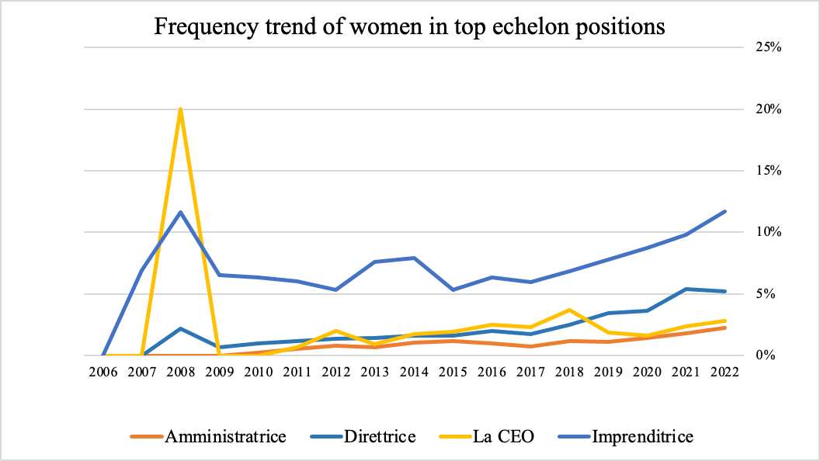

Assuming that the considerations made earlier are also right here, there is a general increase in the use of the terms studied over the years. However, while for the terms amministratrice and direttrice increase is almost constant and continuous, the use of the term la CEO is more discontinuous. We also report how the use of these terms in the feminine is less common than the term imprenditrice, as of 2022 the results are as follows.
- the term amministratrice reached a value equal to 2.2%;
- the term direttrice reached a value equal to 5.2%;
- the term la CEO reached a value equal to 2.8%.
Table 3 presents data on the sentiment analysis of tweets for specific search terms. The data shows that most of the searched words’ tweets are negative, with a total of 670.573 negative tweets, compared to 334.889 positive tweets. This highlights the general perception and sentiment towards the searched words on social media.
The data also shows that the sentiment towards certain searched words, such as imprenditore and imprenditrice, is overwhelmingly negative. However, it is worth noting that the gap between positive and negative tweets narrows for the term imprenditrice with 22.913 positive tweets and 28.872 negative tweets. This may suggest that there is a shift in the public perception and sentiment towards this term, potentially due to the increasing representation and recognition of businesswomen in the professional world.
The data related to positions in the boards shows that most of the searched words’ tweets are negative, with only one exception being the term la CEO, which has more positive tweets (107) than negative tweets (83). The positive sentiment towards the term la CEO is an interesting finding. It suggests that the public perception of female CEOs may be more positive than other corporate positions.
To compare the difference in tweets sentiment between the single keywords within entrepreneur and the other top echelon positions, we calculated the positive comparative advantage index. If this index is greater than 1, it indicates a more positive attitude towards the keyword, if less than 1, a more negative attitude. In the first case can be found more positive attitudes toward imprenditrice (1.80) and more negative attitudes toward imprenditore (0.93). In the second category, there is a more positive attitude toward direttrice, direttore and la CEO (respectively 1.01, 1.17 and 1.10).

Table 3. Number of positive and negative tweets on male and female and positive comparative advantage index.
 | Number of positive tweets | Number of negative tweets | Positive comparative advantage index
Imprenditore | 142,687 | 481,530 | 0.93
Imprenditrice | 22,913 | 28,872 | 1.81
Total | 165,600 | 510,402
Direttore | 103,371 | 94,888 | 1.01
Direttrice | 3,492 | 2,316 | 1.17
Amministratore | 58,123 | 57,187 | 0.98
Amministratrice | 687 | 755 | 0.93
Il CEO | 3,509 | 4,942 | 0.81
La CEO | 107 | 83 | 1.10
Total | 69,289 | 160,171

To study entrepreneur case, we will consider tweets about imprenditore and imprenditrice. For the positions on the boards of firms, we will group together tweets about direttore, il CEO and amministratore for male case, and direttrice, la CEO and amministatrice for the female case.
Calculating the positive comparative advantage index on the total number of tweets (Table 4) and not internally in the two classes we note that for imprenditore and imprenditrice the index is lower at 0.69 and 1.33 respectively. In contrast, for positions on the boards of firms, it is higher at 1.54 for male and 1.73 for female, respectively. In general, the index calculated on the first case (entrepreneur) is lower and equal to 0.74 than that of the second case (positions in the boards of firms) which is 1.54 more than double.

Table 4. Number of positive and negative tweets on male and female classes and positive comparative advantage index.
 | Number of  positive tweets | Number of  negative tweets | Positive comparative advantage index
Imprenditore | 142,687 | 481,530 | 0.69
Imprenditrice | 22,913 | 28,872 | 1.33
Total | 165,600 | 510,402 | 0.74
Male positions in the boards of firms | 165,003 | 157,017 | 1.54
Female positions in the boards of firms | 4,286 | 3,154 | 1.73
Total | 169,289 | 160,171 | 1.54

To assess changes in public perception over time between male and female terms, we will analyze the percentage of positive and negative tweets from a historical perspective. As illustrated in Graph 3, the percentage of negative tweets about imprenditore is consistently higher than the percentage of positive tweets from 2007 to 2022. There were no tweets in 2006. The trend in the percentage of negative tweets remained relatively constant over the years until 2016 when they began to increase from 70% to 81% in 2022.

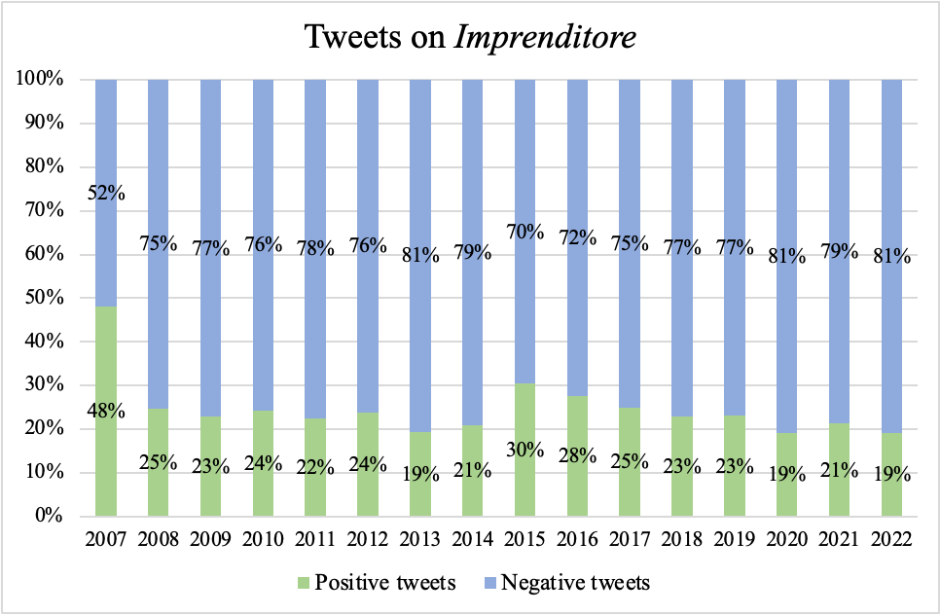
Graph 3. Percentage of positive and negative tweets on Imprenditore between 2007 and 2022.
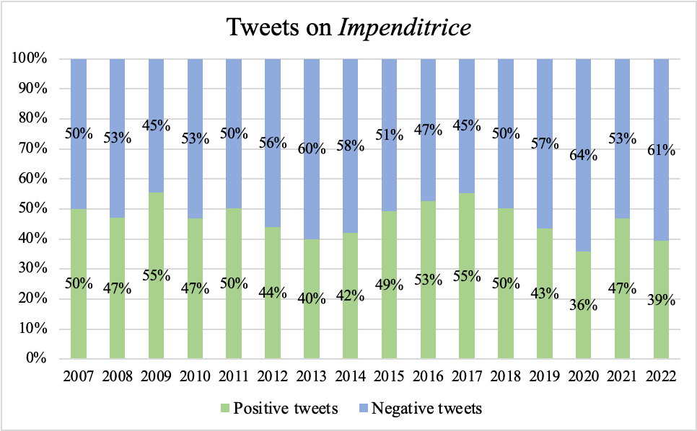
In the case of female entrepreneurs (Graph 4), the difference between positive and negative tweets from 2007 to 2022 is less pronounced. Again, there were no tweets in 2006. From 2017, where negative tweets accounted for 45%, we can see an upward trend in positive tweets, reaching 39% in 2022.
Graph 4. Percentage of positive and negative tweets on Imprenditrice between 2007 and 2022.
For the second category of posts related to positions on the boards of firms (Graph 5), the male cluster shows a rise in positive tweets from 2007 (when those keywords were first used) to 2016, going from 33% to 56%. However, from 2016 to 2022, this trend reversed, and the percentage of positive tweets dropped to 48%.

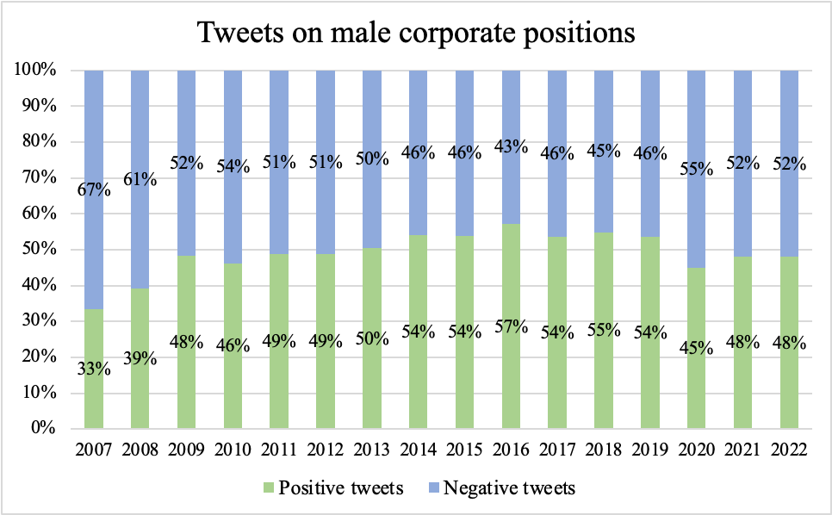
Graph 5. Percentage of positive and negative tweets male positions in the boards of firms between 2007 and 2022.
For the female cluster related to positions on the boards of firms (Graph 6), the trend is variable, with high points of positive tweets in 2013, 2014 and 2015, reaching 62%, 64% and 70% respectively. However, from 2017 to 2022, the trend has been relatively stable.

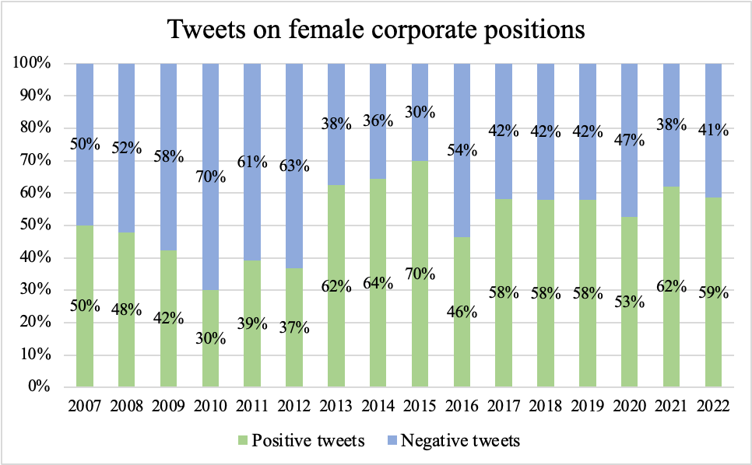
Graph 6. Percentage of positive and negative tweets on female positions on the boards of firms between 2007 and 2022.

7. Discussion and conclusion
Given the ability of language, shown by a good deal of empirical literature, to reinforce or, on the contrary, challenge stereotypes, the use of feminine titles for women’s top echelon positions can promote female presence in such roles. This is especially important given that firms with gender-balanced boards fare better in various aspects. Moreover, feminine job titles align with the general behaviour of Italian personal nouns and are symmetric with respect to the masculine titles used for men. For these reasons, they have been recommended by several private and public bodies. Nonetheless, as Cignarella et al. 2021 showed, they are not proportionate to the presence of women in specific fields. Our study highlights an analogous tendency with respect to top echelon positions.
The results show a predominant use of the masculine form over the feminine one for all analyzed terms. However, we report an increase over time in the percentage of tweets referring to the female form compared to the total use of the term for both genders. This trend, although not always marked, is confirmed for the terms amministratore, direttore, and imprenditore; in contrast, the use of the female form la CEO does not reflect a real increase over the male form, but rather we note a very discontinuous use of the term over time. The positive comparative advantage index is lower for the category of tweets related to entrepreneurs than for the category of positions on the boards of firms. Tweets related to female figures have a higher index signifying a higher positive attitude in both categories. In the first category of entrepreneurs, the difference between imprenditore and imprenditrice is considerable. Negative news tends to generate more attention in the business sector. As more male entrepreneurs are present in the industry, there is a higher likelihood that negative news and comments about their performance will be reported. This can be partly explained by the male figure's tendency to take greater risks in the business environment. Additionally, the greater amount of negative tweets in the category of entrepreneurs may be attributed to the fact that, in the case of imprenditore and imprenditrice, these figures are closely associated with the individual person, whereas in the case of corporate offices, the focus is more on the company as a whole, rather than on individual leaders. As a result, it is easier to express personal opinions and preferences, even negative ones, when referring to the physical person holding the position. Focusing on the time trend, negative tweets about male entrepreneurs, female entrepreneurs and male positions on the boards of firms have increased in recent years, while positive tweets about female positions on the boards of firms have increased. This achievement is thanks to increased awareness regarding gender equality issues in positions on the boards of firms.
A possible future development could include a system capable of assessing, in addition to traditional sentiment analysis, the motivations that cause a user to judge positively or negatively the professional figures being studied. Particularly if the evaluation is driven by the use of language to identify gender, or if more simply the evaluation is about the performance of the professional figure in the work environment.
To increase the data sample, we could download the tweets made by the newspapers with the selected keywords, being that in number will be limited we could provide manual cleaning.

References

ACCADEMIA DELLA CRUSCA (2002), “Accademia della Crusca e la questione del genere nella lingua”.
AGENZIA DELLE ENTRATE (2020), Linee guida per l’uso di un linguaggio rispettoso delle differenze di genere.
ALESINA A., CARLANA M., FERRARA E.L., PINOTTI P. (2018), Revealing Stereotypes: Evidence from Immigrants in Schools, National Bureau of Economic Research, Cambridge, MA, No. w25333.
BAXTER J. (2010), The language of female leadership, Palgrave Macmillan, Basingstoke.
BELLE D., TARTARILLA A.B., WAPMAN M., SCHLIEBER M., MERCURIO A.E. (2021), ““I Can’t Operate, that Boy Is my Son!”: Gender Schemas and a Classic Riddle”, Sex Roles, vol. 85, n. 3–4, pp. 161–171.
BELLODI E., BERTAGNON A., GAVANELLI M. (2022), “Comparing emotion and sentiment analysis tools on italian anti-vaccination for covid-19 posts”, Proceedings of the Sixth Workshop on Natural Language for Artificial Intelligence (NL4AI 2022) co-located with 21th International Conference of the Italian Association for Artificial Intelligence (AI* IA 2022).
BOHREN J.A., IMAS A., ROSENBERG M. (2019), “The Dynamics of Discrimination: Theory and Evidence”, American Economic Review, vol. 109, n. 10, pp. 3395–3436.
BORDALO P., COFFMAN K., GENNAIOLI N., SHLEIFER A. (2016), “Stereotypes*”, The Quarterly Journal of Economics, vol. 131, n. 4, pp. 1753–1794.
CARLANA M. (2019), “Implicit Stereotypes: Evidence from Teachers’ Gender Bias*”, The Quarterly Journal of Economics, vol. 134, n. 3, pp. 1163–1224.
CIGNARELLA A.T., LAI M., MARRA A., SANGUINETTI M. (2021), “"La ministro è incinta”: A Twitter Account of Women’s Job Titles in Italian”.
COFFMAN K.B. (2014), “Evidence on Self-Stereotyping and the Contribution of Ideas*”, The Quarterly Journal of Economics, vol. 129, n. 4, pp. 1625–1660.
CORRELL S.J., WEISSHAAR K.R., WYNN A.T., WEHNER J.D. (2020), “Inside the Black Box of Organizational Life: The Gendered Language of Performance Assessment”, American Sociological Review, vol. 85, n. 6, pp. 1022–1050.
DE FRANCISCO V.L. (1992), “Deborah Tannen, You just don’t understand: Women and men in conversation. New York: William Morrow & Co., 1990. Pp. 330.”, Language in Society, vol. 21, n. 2, pp. 319–324.
DUTT K., PFAFF D.L., BERNSTEIN A.F., DILLARD J.S., BLOCK C.J. (2016), “Gender differences in recommendation letters for postdoctoral fellowships in geoscience”, Nature Geoscience, vol. 9, n. 11, pp. 805–808.
EFFEQU (2020), Lo schwa secondo noi.
EKMAN P. (1992), “An argument for basic emotions”, Cognition and Emotion, vol. 6, n. 3–4, pp. 169–200.
GIUSTA M.D., BOSWORTH S. (2020), “Bias and discrimination: what do we know?”, Oxford Review of Economic Policy, vol. 36, n. 4, pp. 925–943.
GYGAX P., ZUFFEREY S., UTE G. (2021), “Le cerveau pense-t-il au masculine?”, Le Robert.
HENTSCHEL T., HORVATH L.K., PEUS C., SCZESNY S. (2018), “Kick-Starting Female Careers: Attracting Women to Entrepreneurship Programs”, Journal of Personnel Psychology, vol. 17, n. 4, pp. 193–203.
HORVATH L.K., SCZESNY S. (2016), “Reducing women’s lack of fit with leadership positions? Effects of the wording of job advertisements”, European Journal of Work and Organizational Psychology, vol. 25, n. 2, pp. 316–328.
JOHN AUSTIN (1962), How to do things with words.
LAKOFF R. (1973), “Language and woman’s place”, Language in Society, vol. 2, n. 1, pp. 45–79.
MILLS S. (2008), Language and sexism, 1. publ., Cambridge Univ. Press, Cambridge.
MIUR (n.d.), Linee Guida per l’uso del genere nel linguaggio amministrativo del MIUR.
MOREHOUSE K.N., KURDI B., HAKIM E., BANAJI M.R. (2022), “When a stereotype dumbfounds: Probing the nature of the surgeon = male belief”, Current Research in Ecological and Social Psychology, vol. 3, p. 100044.
MOULTON J. (1981), “The Myth of the Neutral “man””, Vetterling-Braggin.
ROBUSTELLI C. (2012), Linee guida per l’uso del genere nel linguaggio amministrativo.
ROCCABRUNA G., AZZOLIN S., RICCARDI G. (2022), “Multi-source Multi-domain Sentiment Analysis with BERT-based Models”, Proceedings of the Thirteenth Language Resources and Evaluation Conference. European Language Resources Association., pp. 581–589.
SAPEGNO M.S. (2010), Che genere di lingua? Sessismo e potere discriminatorio delle parole.
SCZESNY S., FORMANOWICZ M., MOSER F. (2016), “Can Gender-Fair Language Reduce Gender Stereotyping and Discrimination?”, Frontiers in Psychology 7: 25.
SHAMBAUGH R. (2008), It’s not a glass ceiling, it’s a sticky floor: free yourself from the hidden behaviors sabotaging your career success, McGraw-Hill, New York.
SULIS G., GHENO V. (2022), “The Debate on Language and Gender in Italy, from the Visibility of Women to Inclusive Language (1980s–2020s)”, The Italianist, vol. 42, n. 1, pp. 153–183.
VERVECKEN D., HANNOVER B. (2015), “Yes I Can!: Effects of Gender Fair Job Descriptions on Children’s Perceptions of Job Status, Job Difficulty, and Vocational Self-Efficacy”, Social Psychology, vol. 46, n. 2, pp. 76–92.
VERVECKEN D., HANNOVER B., WOLTER I. (2013), “Changing (S)expectations: How gender fair job descriptions impact children’s perceptions and interest regarding traditionally male occupations”, Journal of Vocational Behavior, vol. 82, n. 3, pp. 208–220.
WU A.H. (2018), “Gendered Language on the Economics Job Market Rumors Forum”, AEA Papers and Proceedings, vol. 108, pp. 175–179.

Other realistic (but less common) options include the boy having two fathers, being either one biological and one adoptive/stepfather or a gay couple. However, Belle et al. 2021 and Morehouse et al. 2022 also recorded irrational answers where participants imagined that the surgeon could be a ghost or priest and interviewees in a recent (2017) BBC video (https://www.facebook.com/watch/?v=10154573248485787) even hypothesized that it could be God.
It is important to point out that empirical studies in the field of psychology have, in general, several limitations. Indeed, they tend to have a small number of participants, and they are conducted in a setting that differs from everyday life. Although the mentioned studies share these general limitations of cognitive science experiments, they nonetheless provide an interesting perspective on the issue. Moreover, the results on the effects of masculine terminology are quite robust since they have been found in a vast number of studies and through a variety of methodologies.
There is a handful of nouns that only occur in one gender due to linguistic reasons: e.g., “personaggio” (character) is masculine and “guida” (guide) is feminine regardless of the gender of their referent. The former is a loan word and the latter a meaning extension and they owe their gender, respectively, to the foreign term and the primitive word they derive from.
For instance, no one would call a male nurse “infermiera” (nurse, feminine). Sara Mills reports this interesting case from Pauwels (1998) concerning German: “‘die Hebamme’ used to be the word for midwife. When men began to work as midwives, this was changed to ‘Entbinungspfleger’. For women to refer to themselves as midwives, they had to add a feminine affix to the word, making for the much more unwieldy and masculine-derived ‘Entbinungspflegerin’ (see also Hellinger ans Bussmann, 2001).” (Mills 2008: 51).
Moulton imputes this fact to the marked character of feminine words, that is to the fact that feminine terms, unlike masculine ones, can only be used to denote females. Indeed, as she points out, “the unmarked term of a pair of opposites has higher positive associations. The use of a marked term often has a pejorative tone.” (Moulton 1981: 129). See Schultz (1990) for an in-depth investigation of the mechanisms behind derogating feminine terms.
For an overview of all the formation rules of feminine forms see, among others, Robustelli (2014), pages 43 and following; Marcato and Thüne (2002), pages 191 and following; or the entry “femminile” (feminine) in the column “la parola del giorno” (the word of the day) on the website https://dizionaripiu.zanichelli.it
The authors created the FEEL-IT corpus by manually classifying 1000 tweets collected from August 20 to October 12 2020 (Bianchi et al. 2021).

